**INDIAN WILDLIFE**

**A PROJECT REPORT**

*submitted by*

**Name(s):**

**SAXAM TRIKHA**

**SURAJ RISHI**

**(Reg. No)**

**12BCE0003**

**12BCE0210**

**Faculty:**

**Prof. LYDIA JANE**

**Slot:**

**B2**

**Software Engineering**

**CSE325**

**VIT**

U N I V E R S I T Y

(Est. u/s 3 of UGC Act 1956)

Vellore - 632 014, Tamil Nadu, India

**School of Computing Science and Engineering**

APRIL 2015

1. Introduction

1.1 Abstract

1.2 Purpose

1.3 Literature Survey

1.4 Definitions, Acronyms & Abbreviations

2. Planning & Scheduling

2.1 SDLC model

2.2 Gnatt Chart

2.3 PERT Chart

2.4 Timeline Chart

3. Software Requirements Specification

3.1 Functional Requirements

3.2 System Requirements

3.3 Non-Functional Requirements

3.4 Assumptions & Constraints

4. Software Design Specification

4.1 Architecture Design

4.2 Component/Module Design

4.3 System Models

4.4 User Interface Design

4.5 Alternate Designs

5. Coding

6. Testing

6.1 Test Cases

6.2 Test Execution Report

6.3 Automated Testing Tools - A study

7. Configuration Management

8. Conclusion

# Introduction

## Abstract

The project consists of a website which essentially contains information about the diverse wildlife of India. The website will display information about endangered species. It will also enable a user to register himself to the website, and further allow him to post relevant information on the blog and also make donations for various causes.

## Purpose

We aim to create an amusing website for promoting awareness and conservation of India’s wildlife. Apart from arousing the awareness it will posses detailed information on various rare Indian animals along with coverage of all species of animals that roam in the woods of INDIA. With this, it will act as a platform for wildlife conservationists and ecologists to share their knowledge and recent trends in this field. It will incubate research and participation on subjects like animal communications, habitats, wildlife health issues, effects of global warming and various disasters.

## Literature Survey

## Current System or Situation

* The need for conservation of wildlife in India is often questioned because of incorrect priority in the face of direct poverty of people.
* Large and charismatic mammals are really important for tourism in India.
* The tiger's population in India has dwindled from 40,000(early 1900s) to only around 1700(2010).
* There are other 47 critically endangered species (as of 5th September, 2011) according to the RED DATA BOOK of IUCN.
* Creation of awareness among people about these endangered species is really important to stop them from getting killed.

## Project Scope

* The website will create awareness of the above stated problems to the general public.
* It will give detailed information on various rare Indian animals along with coverage of all the species.
* It will facilitate members to form groups to organize local meetings, wildlife forums, periodicals etc.
* It will give users space to post their recent wildlife success stories, blogs, internships, conferences.

# Planning & Scheduling

## SDLC model

We have chosen to follow the **incremental model** for this project.

In incremental model the whole requirement is divided into various builds. Multiple development cycles take place here, making the life cycle a "multi- waterfall" model .  Cycles are divided up into smaller, more easily managed modules.  Each module passes through the requirements, design, implementation and testing phases. A working version of software is produced during the first module, so you have working software early on during the software life-cycle. Each subsequent release of the module adds function to the previous release. The process continues till the complete system is achieved.

## Gantt Chart

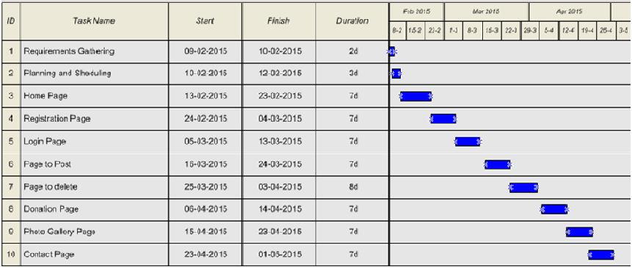

## PERT Chart

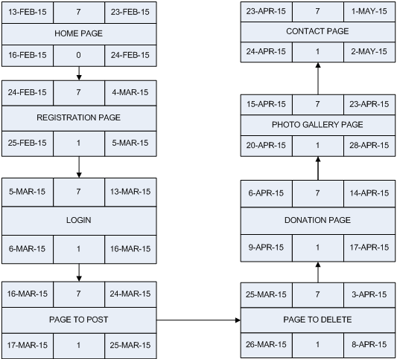

# Software Requirements Specification

## Functional Requirements

### Stakeholders

* Anonymous users
* Group members (registered users)
* Government and private organizations, Wildlife conservationist, ecologists, veterinarians and wildlife enthusiasts.
* Site administrators.

### Modules

* Anonymous access to the website.
* Provide users with option to register themselves.
* Users- Log in, post photos and information.
* Provide option for donation to various NGO’s.
* Top Stories.
* News about camps, meetings etc.
* Newsletters.
* Gallery Access
* Information about Careers.

### User stories/requirements

* To monitor statistics related to endangered species, jeopardized habitats, unbalanced ecosystems and unfavourable climatic changes.
* To facilitate members to form groups to organize local meetings, wildlife forums, periodicals and Wildlife camps.
* To provide a space for registered users to post interesting photos, videos and presentations on Indian Wildlife.
* Secure registration and profile management facilities for registered members and government and non-government agencies.
* To acquaint users with various career opportunities in the field of Wildlife, along with a list of universities offering Wildlife Degrees, fellowships and certifications.
* NGOs can use it for the following :

1. Information about upcoming awareness drives
2. Opportunities in volunteer work.

* It will portray recent wildlife success stories with an opportunity for users to participate in Wildlife logs, forums, internships, conferences and other awareness programs.
* To set up a reviewer’s panel that will be responsible for solving various queries of website users.

### Requirement Analysis

#### Use Case Diagram

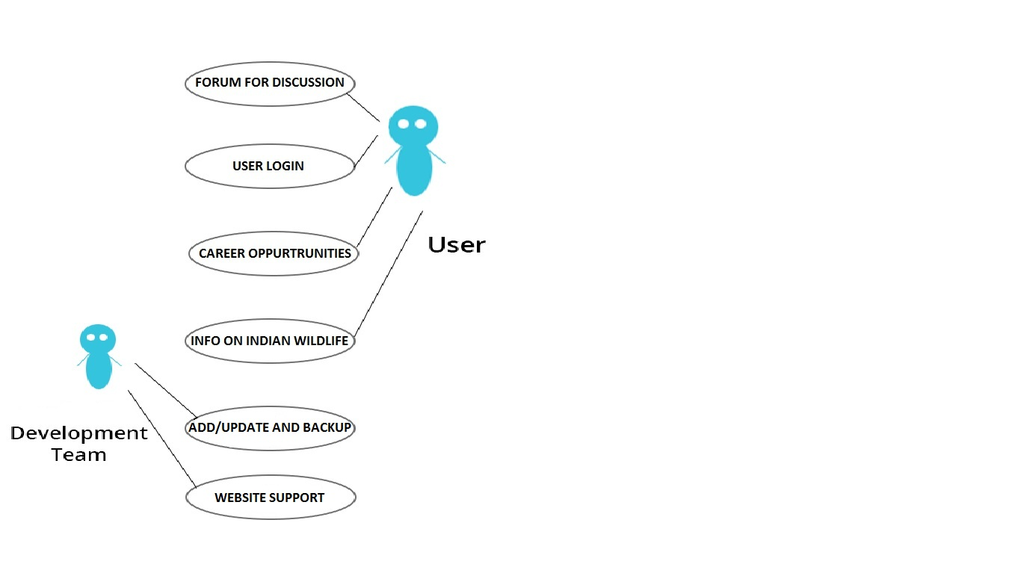

#### Sequence Diagram

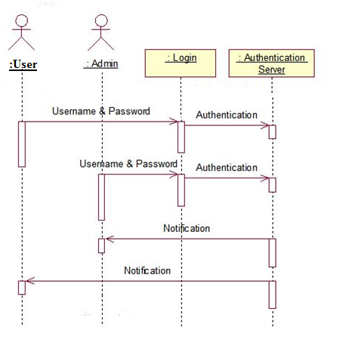

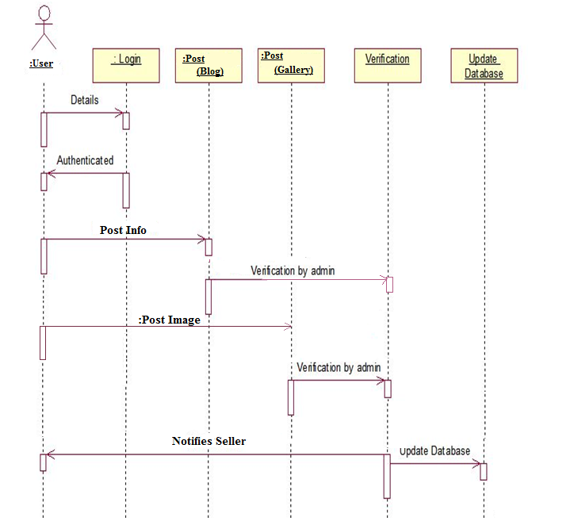

## System Requirements

Hardware Requirements

* Minimum RAM: 512 MB
* Minimum disk space: 500 MB
* Processor Intel Core 2 DUO 2.4 GHz minimum

Software Requirements

* Windows xp and above
* Notepad++
* Browser- Mozilla, Firefox, Safari, Internet Explorer
* Microsoft Visio 2010
* 24X7 internet availability

## Non-Functional Requirements

* Accessibility: The website will be accessible to everybody, with no restrictions. The website can be accessed using any of the following browsers: Google Chrome, Mozilla Firefox and Internet Explorer (Version 8 and above).
* Security: The website will provide secure registrations to the users. No user details will be shared with a third party. The donations to non-profit organizations will be made through safe and secure gateways.
* Usability: The website will be attractive and user friendly. Graphical representation of Wildlife Surveys on species, climates, lands and ecologies will be provided for better understanding.
* Price: The website will have no registration fees of any kind. All the features of the website will be available to the user for free.
* Scalability: The website will be designed keeping in mind the needs of the user, better component design to get better performance at peak time. The website will have flexible service based architecture that will be highly desirable for future extension.

# Software Design Specification

## Architecture Design

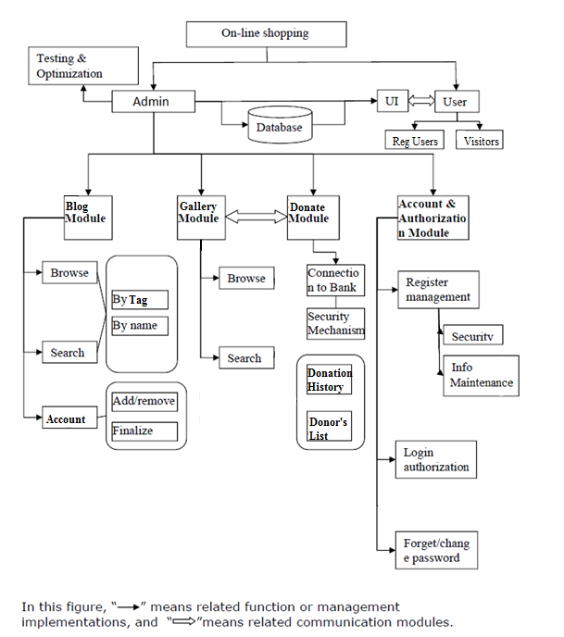

## System Models

### Data Flow Diagram

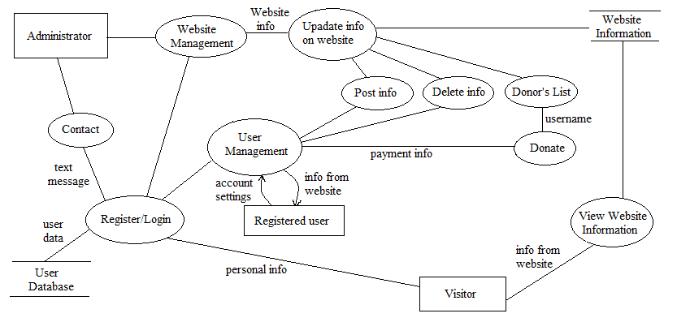

### Data Model

#### Database Description

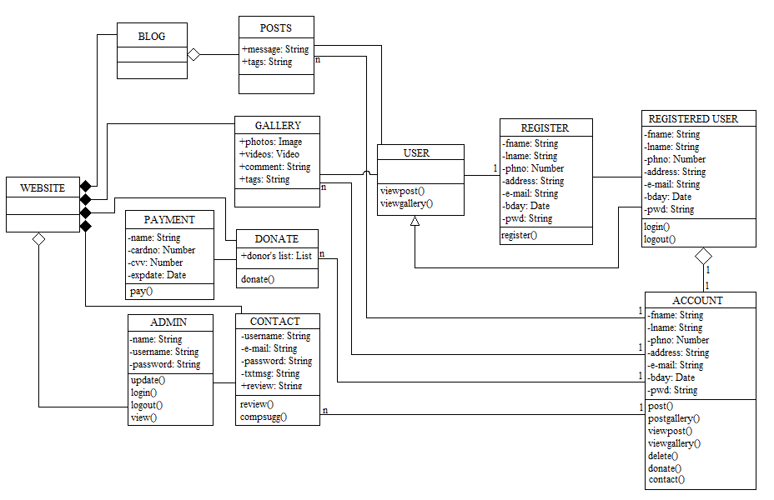

## User Interface Design

1. 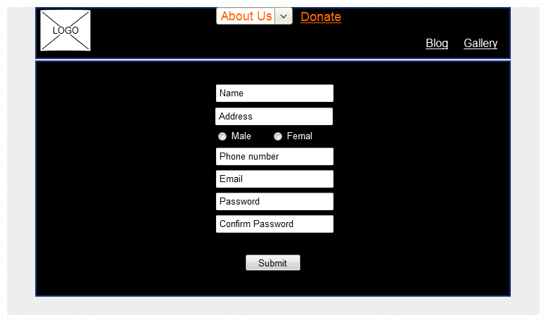

2.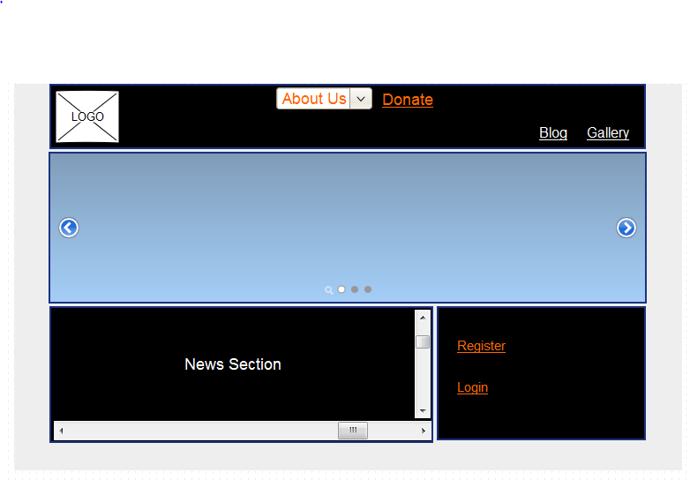

3

3.

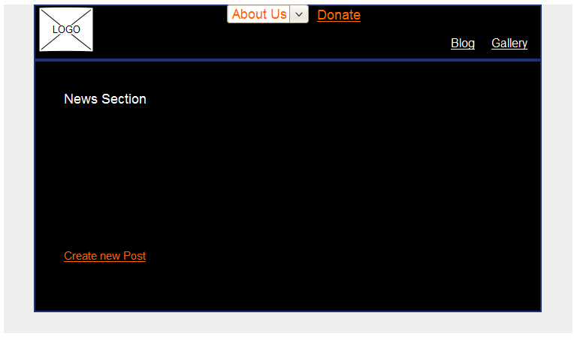

4.

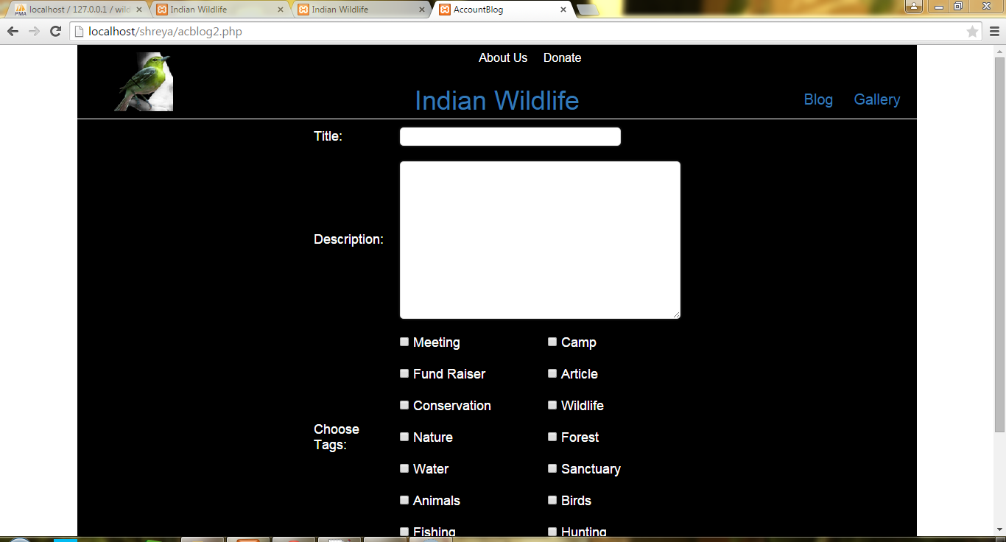

## Alternate Designs

* Other alternate design methods/solutions available for the current scenario. Why were the other designs not chosen and justification on the chosen solution
* Ex: client side checking Vs Server side checking and etc.,

# Coding \

# C:\Users\hp\Desktop\Code.png

# Testing

## Test Cases

|  |  |  |  |  |  |
| --- | --- | --- | --- | --- | --- |
| **Test Case ID** | **Test Objective** | **Test Data** | **Expected Results** | **Actual Results** | **Test Pass/Fail** |
| 1. | Registration to Website  (Entering Details) | Enter User Personal Information | The Website should check for proper information entered. | The website checks for incorrect information and informs the user if so. | Pass |
| 2. | Registration  (User details stored in Database) | User Information | When the submit button is clicked on registration form, the entered details (valid) are stored in database | The website stores the user details in the database correctly. | Pass |
| 3. | Login to website | User’s username and password | The system checks if the correct username and password combination is entered. | The Website allows the user to access the website through the account if correct information is entered. | Pass |
| 4. | Post a blog | User’s login information and Blog information | The system ensures correct information is entered and posts the new blog on the website. | The new blog should appear on the blog webpage and in the news section on homepage. | Pass |
| 5. | Contact the administrator | User’s login information and feedback | The system should validate the provided information and store the information in the website. | The system validates the information and stores the information under contact table in database. | Pass |
| 6. | Donate | User information and amount. | The system should validate the data. | The system allows its users to donate by entering user information. The data is stored in the database. | Pass |

# Configuration Management

* Notepad++ for front-end.
* XAMPP for backend.
* Latex for SDS.
* Microsoft VISIO for Scheduling Diagrams.
* Pencil for GUI Design.
* Rational Rose for design diagrams.

# Conclusion

The website for Indian Wildlife was created and run successfully. A majority of the proposed functionalities were implemented within the time period afforded to us.